PROJECT REPORT

INTRODUCTION

OVERVIEW

This project contains IPHONE product name, rating, Discount of the product, ram and URL details and their growth.

PURPOSE

The purpose of the project is develop the technical advance of the IPHONE

PROBLEM DEFINITION & DESIGN THINKING

BRAIN STORM

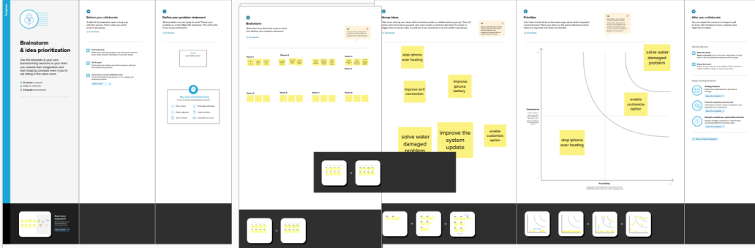

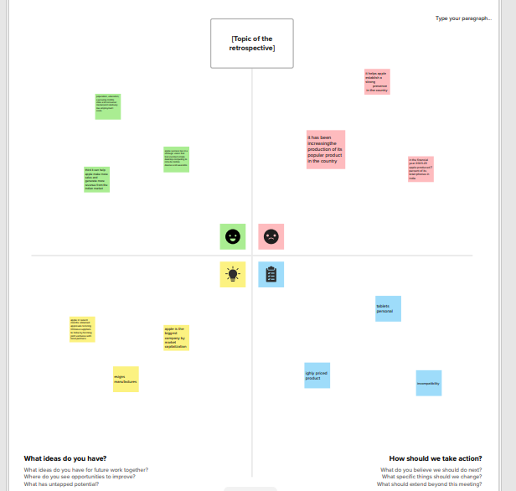EMPATHY MAP

RESULT

Dashboard

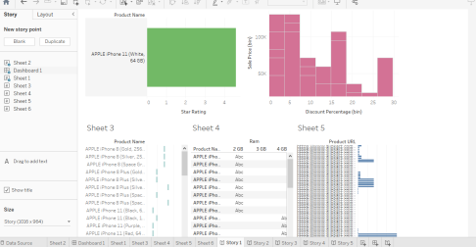

Story

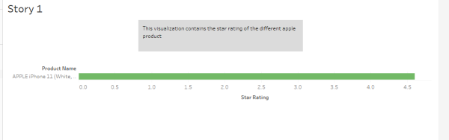

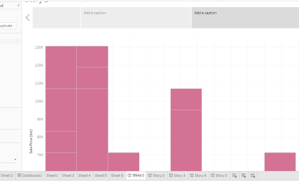

ADVANTAGES & DISADVANTAGES

This project contains for IPHONE benefits and their growth. This project also contains IPHONE recent problems. This project is helpful for all about details of APPLE IPHONE. This project shows only current status of the IPHONE.

APPLICATION

The project shows for rating of the IPHONE product details.it is help for how to reach the product in people.

CONCLUSION

The project explain IPHONE product and their details. This project contains advantages and Disadvantages of the IPHONE.